DUAL CODEC CMOS IR
Network Camera

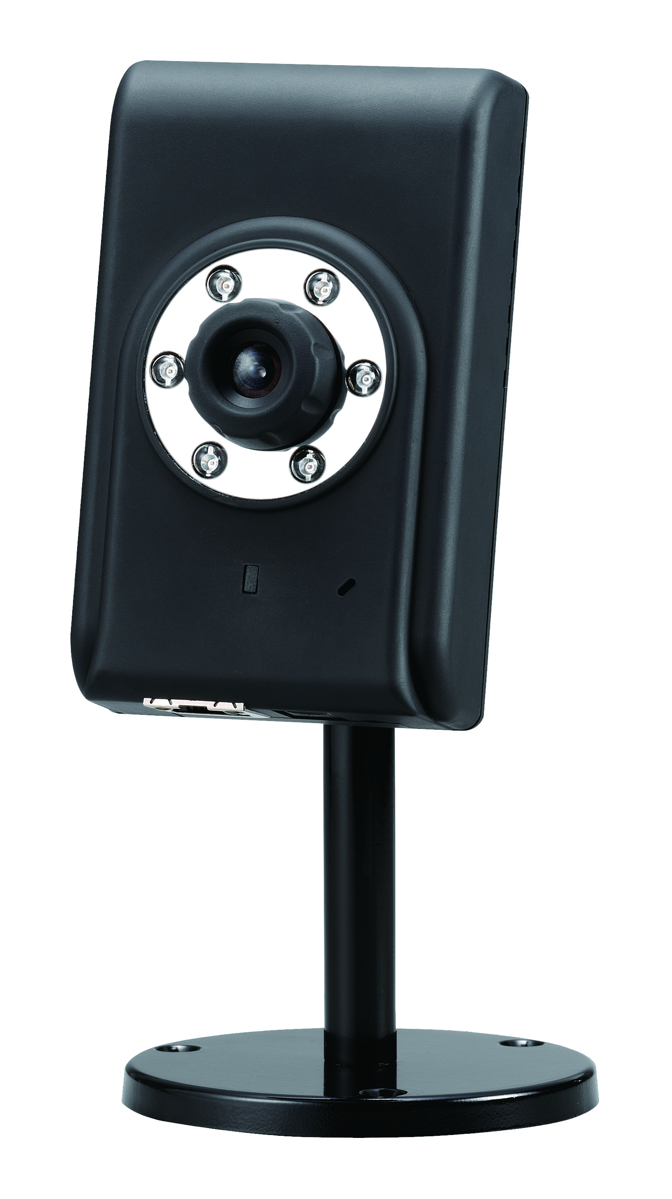

Quick Installation Guide

Before installation, please be sure to read this quick installation guide and user’s manual carefully to complete machine installation.

System Requirements
DUAL CODEC CMOS IR Network Camera
Network Environment
 | Wired Model
LAN | 10/100MBase-TX Ethernet
Monitoring System Recommended for Internet Explorer
System Hardware | · CPU: Pentium 4, 2GHz or above  · Memory Size : 128 MB (256 MB or above Recommended )  · VGA card resolution : 1024 x 768 or above
System Requirement for Viewer & Recorder Application
Support OS | Win 2000 , Win XP
System Hardware | 1-4 cameras surveillance application  · CPU: Pentium 4, 2GHz or above  · Memory Size : 256 MB or above  · VGA card resolution : 1024 x 768 or above

Physical Installation
- Connect an Ethernet cable
Method 1. Connect one end of the cross over cable (in accessory, red color cable) to the LAN port located on the Network Camera’s bottom and attach the other end to your PC
Method 2. Connect one end of the Ethernet cable to the LAN port located on the Network Camera’s bottom and attach the other end to the net-work device (hub or switch).
Note:
Your PC’s ip address may be changed in order to connect to the network camera. Please refer to page 4 of Quick Guide for the detail.

- Attach the power supply
Connect the provided power adapter labeled “5V DC” to the Network Camera connector on bottom and then plug into AC power socket.

- Check the LED ( Front Panel )
The LED on the front panel would be ON, and the 10/100 LED would flash for few times to detect network connection. The network indication LEDs would be on depending on which network type is available.
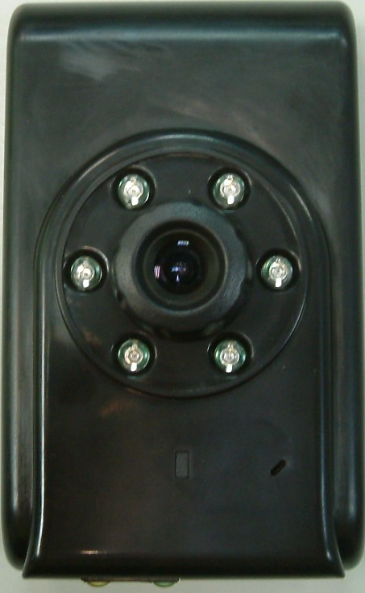
Network Accessing Type LED
Microphone

- Real Panel LED Definition

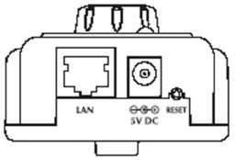
Real Panel of Dual CODEC IP Camera

LAN Port 2pcs LEDs

 | LANJACK STATUS | GREEN LED  (Link / Active) | ORANGE LED  (10M/100M)
10Mbits | Remove cable | Dark | Dark
10Mbits | Plug in cable | Bright | Dark
10Mbits | Plug in & Access | Blinking | Dark
100Mbits | Remove cable | Dark | Dark
100Mbits | Plug in cable | Bright | Bright
100Mbits | Plug in & Access | Blinking | Bright
LED Definition:

5. Place the Camera on the table or fix it onto ceiling or wall
Use screws to fix the Network Camera onto the ceiling or wall. You could also put the Network Camera on the table directly.

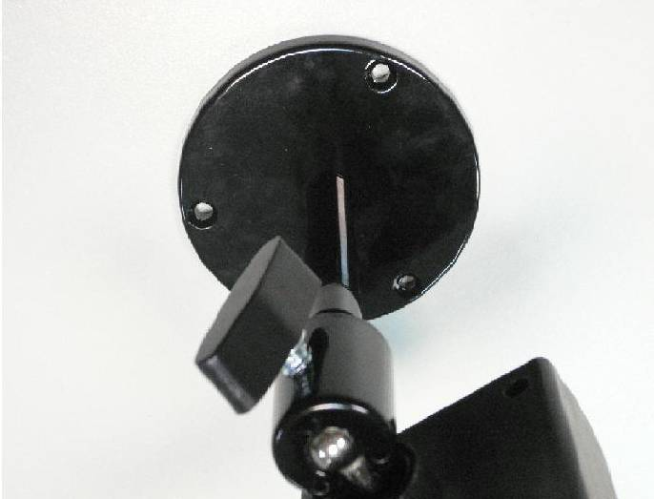
Fixed it by screws

Camera administration
The Network Camera provides GUI ( Web based, Graphical User Interface ) for machine management and maintenance.

When you installed your IP camera over your network environment, to start Network Camera web configuration, you must have the web browsers installed on computer for web management.

- Microsoft internet Explorer 5.5 or higher with Java support

Default LAN interface IP address of Network Camera is 192.168.0.20. You may now open your web browser, and key in http://192.168.0.20 in the address bar of you web browser to logon Network Camera’s web configuration page.

The Network Camera will prompt for User Name and Password. For the first time, please enter: admin as username and admin as password to continue machine Web Management.

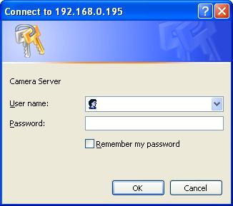

If difficulty is met, please refer to the following steps to establish the connection:
- Your PC can establish a physical connection to the Network Camera. The PC and the Network Camera must be directly connected (using the cross over cable included in the package.) or on the same LAN segment. That is the PC must be configured to an IP address and subnet mask in 192.168.0 x (x=2~254, but not 20) segment. For example: IP: 192.168.0.2, subnet mask : 255.255.255.0.
- Following two photos show you how to find out current ip address of your PC, please write the address onto paper before you change it.
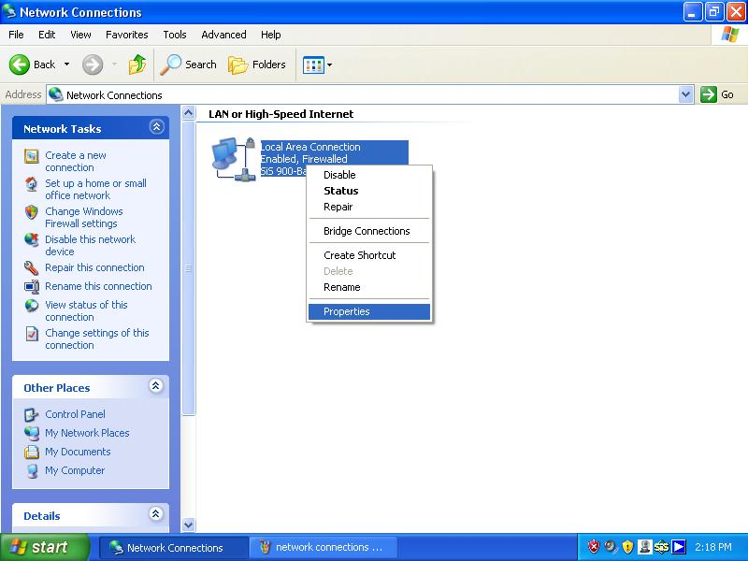

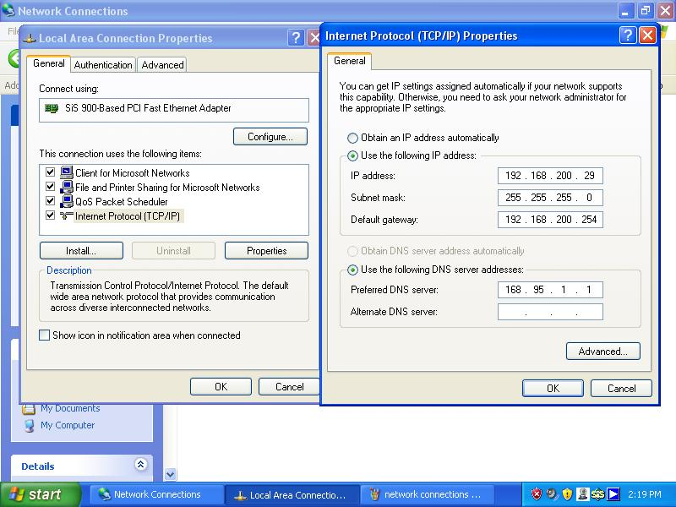
- The Network Camera must be installed and powered ON.

- If the Network Camera’s default IP Address (192.168.0.20) is already used by another device, the other device must be turned OFF until the Network Camera is allocated a new IP Address during configuration.

Or you may execute MPEG4 IP Finder to discover Network Camera’s IP address. MPEG4 IP Finer can only discover Network Camera which is in the same LAN network:
Procedures of MPEG4 IP Finder utility

- Please find the MPEG4 IP Finder in the Utility folder on user s manual CD
- Double-click the MPEG4 IP Finder and the following screen should be prompt on your computer.
- Choose the destination camera for IP address and device name modifications.
- Press “Submit” button to activate these settings.

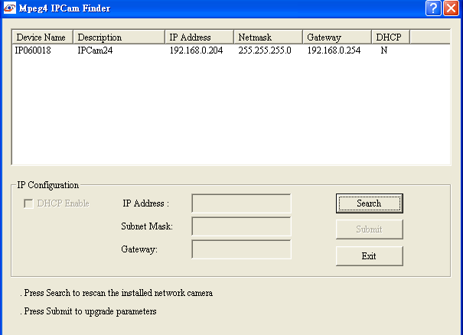

- After modifications, you may now connect the camera via web browser.

Note: The Login Window of the Network Camera is displayed:
For the first time use (default value), input the
User Name: admin
Password: admin

Quick view table of camera’s applications

What do you want to do? | Quick viewing
View the camera from the Internet  (Router’s settings) | Refer to the user’s manual, Page 20
DDNS settings | Refer to the user’s manual, Page 35 and 63
Turn on or scheduling the built-in IR LED | Refer to the user’s manual, Page 39
Add users | Refer to the user’s manual, Page 41
Motion detection settings  (Send files to FTP or by e-mail) | Refer to the user’s manual, Page 42
Upgrade firmware | Refer to the user’s manual, Page 47
Recording by IE | Refer to the user’s manual, Page 50
Recording by software | Refer to the user’s manual of Liveplayer

Please read the user’s manual for the detail settings of this camera.

Made in Taiwan
All Rights Reserved 2006



